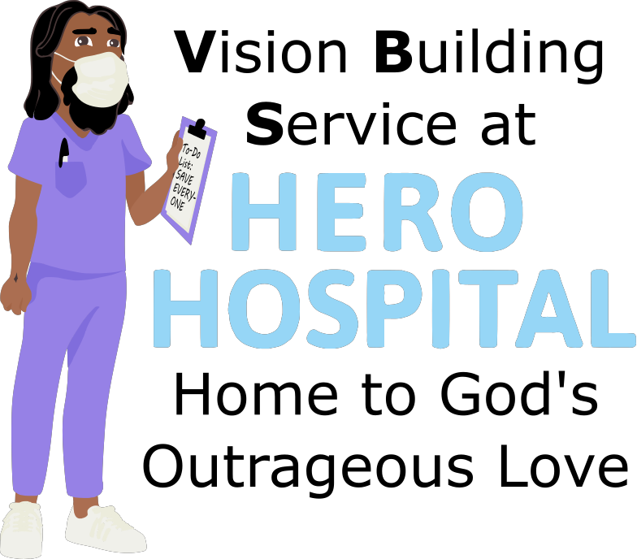
This week at Hero Hospital, we'll be learning that God's Kingdom is a
place for Discovery!
Instructions for activities are found at: bannerblue.org/herohospital
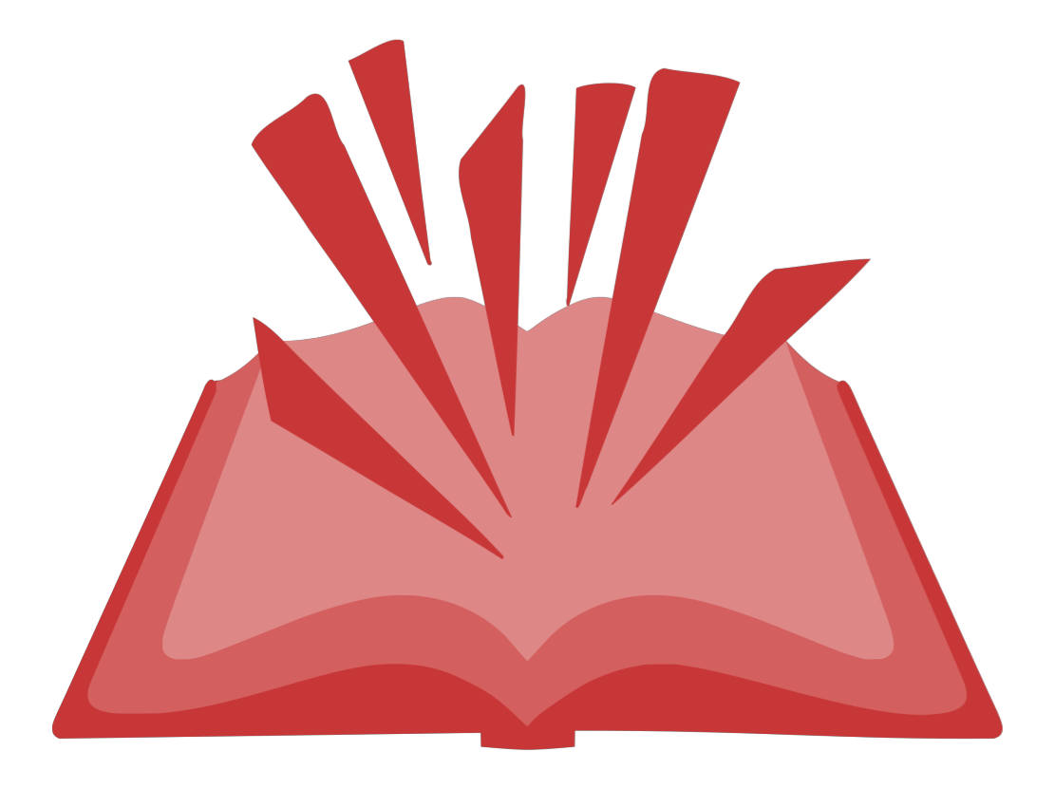
In Story, we'll learn from our historical guide Hildegard and hear how Jesus shows us that through trust, cooperation, and creativity we can discovery new ways to help each other!
Provided Supplies: Builder Book and Builder Bricks.

In Science, we'll explore how our hearts work.
Provided Supplies: Builder Book and Builder Bricks, pencil, paper.
Supplies from Home: Flashlight, stopwatch (you can use the stopwatch in the clock app on your phone or tablet.

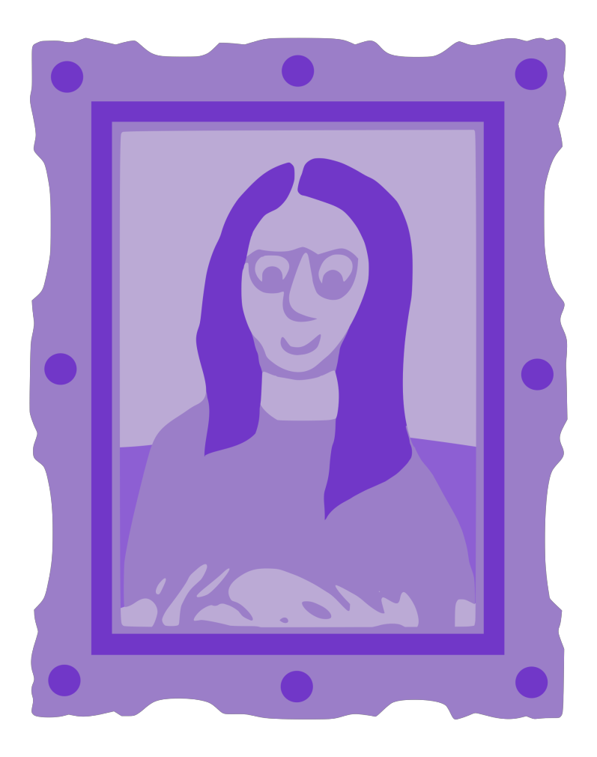
In Art, we’ll make stickers for blood donors.
Provided Supplies: Builder Book and Builder Bricks, markers, Sticker Template, blank stickers
*Kids can keep a few finished stickers for themselves. Please bring the other finished stickers back to Church so we can give them to people at the Fall Blood Drive.
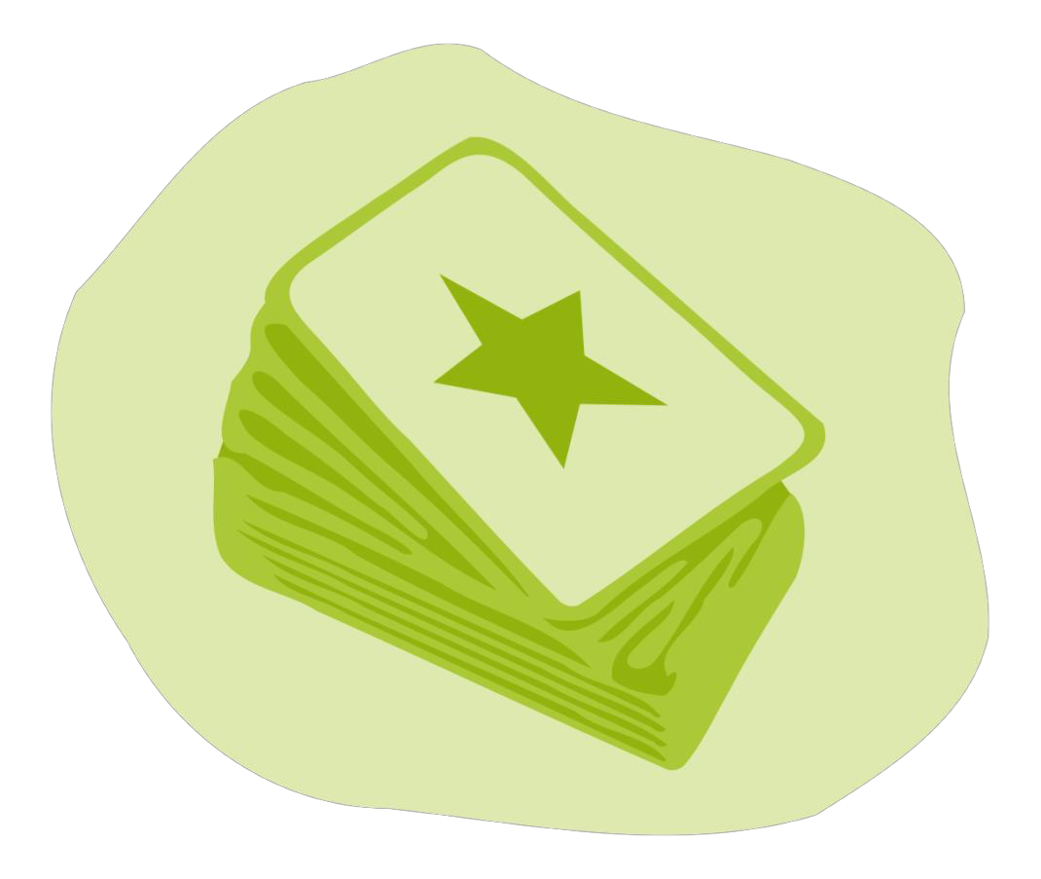
In Games, we’ll put a fun spin on Candy Land or Clue by using the Gospel Rules! Or you can find a creative version of tag on the website.
Provided Supplies: Builder Book and Builder Bricks.
Supplies from Home: Candy Land or Clue.

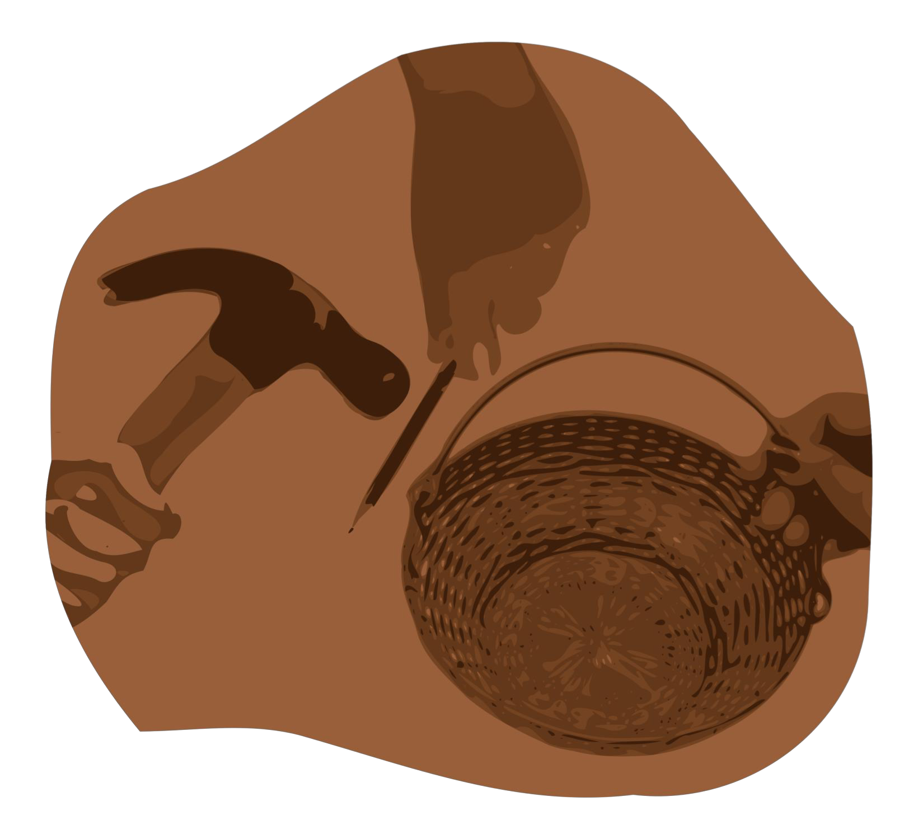
After learning about how Jesus wants us to make the world a better place by living out our faith, we’ll be inspired to do a Big Church Project! This week we’ll be inspired to host a blood drive at church. Kids are invited to ask Pastor Katie about this when they return next week!
Provided Supplies: Builder Book and Builder Bricks.
During Worship we’ll sing and dance along with our VBS Music. Kids can also listen to the Music on the Hero Hospital website.
Provided Supplies: Builder Book and Builder Bricks.

After sharing all of these activities and learning about faith during worship and at home with their families, our kids will be able to answer this week’s Big Question: Why do some people recover from an illness or disability when others don’t?
Provided Supplies: Builder Book and Builder Bricks.

Remember to bring back your finished art and science activities for Show and Tell!

