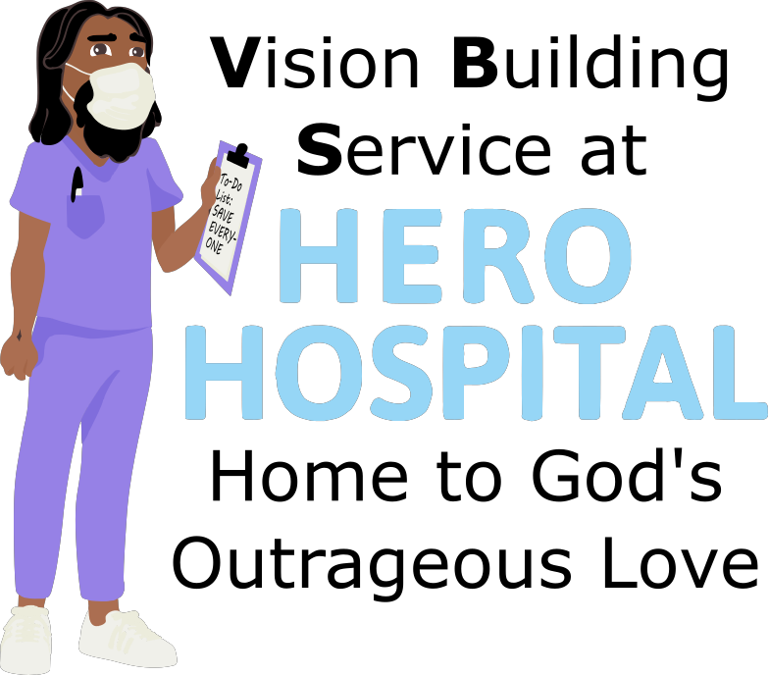
This week at Hero Hospital, we'll be learning that God's Kingdom is a
place for Praise!
Instructions for activities are found at: bannerblue.org/herohospital
In Story, we'll learn from our historical guide Cecilia and hear how Jesus praised God by helping and loving others!
Provided Supplies: Builder Book and Builder Bricks.
In Science, we'll explore how our bodies rest to recharge.
Provided Supplies: Builder Book and Builder Bricks, paper, pencil.
Supplies from Home: Spoon, ceramic plate or baking sheet.

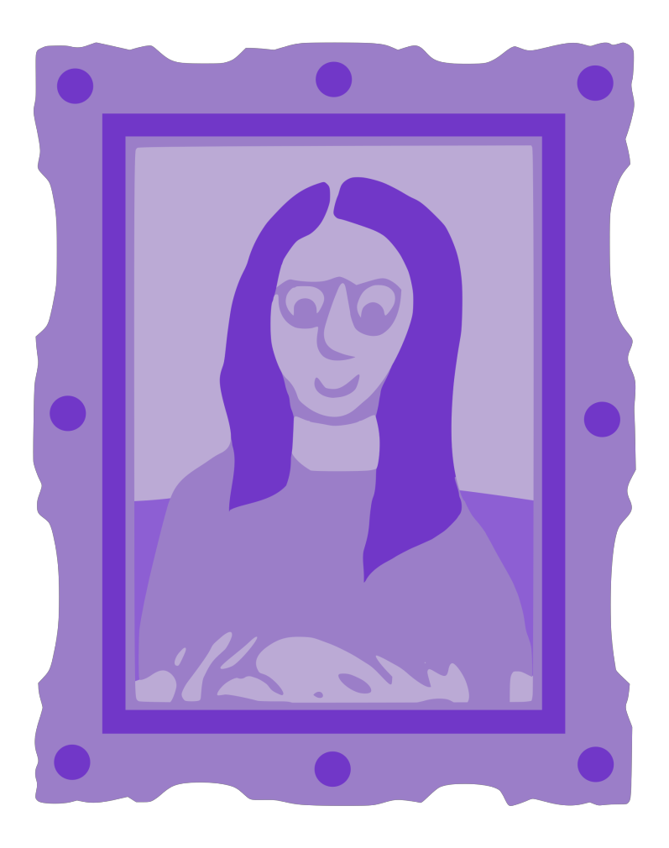
In Art, we’ll make “You Rock!” rocks.
Provided Supplies: Builder Book and Builder Bricks, 3 rocks, paint, brushes.
*Bring your rocks back on Sunday, July 18th and we’ll seal them with a clear spray. 1 Rock is for kids to keep for themselves, 1 Rock will be given to a member of our church family who works in Education, and 1 Rock is for kids to give to someone that they want to share God’s love with!
In Games, we’ll put a fun spin on Checkers or Battleship by using the Gospel Rules! Or you can find a creative version of tag on the website.
Provided Supplies: Builder Book and Builder Bricks.
Supplies from Home: Checkers or Battleship.

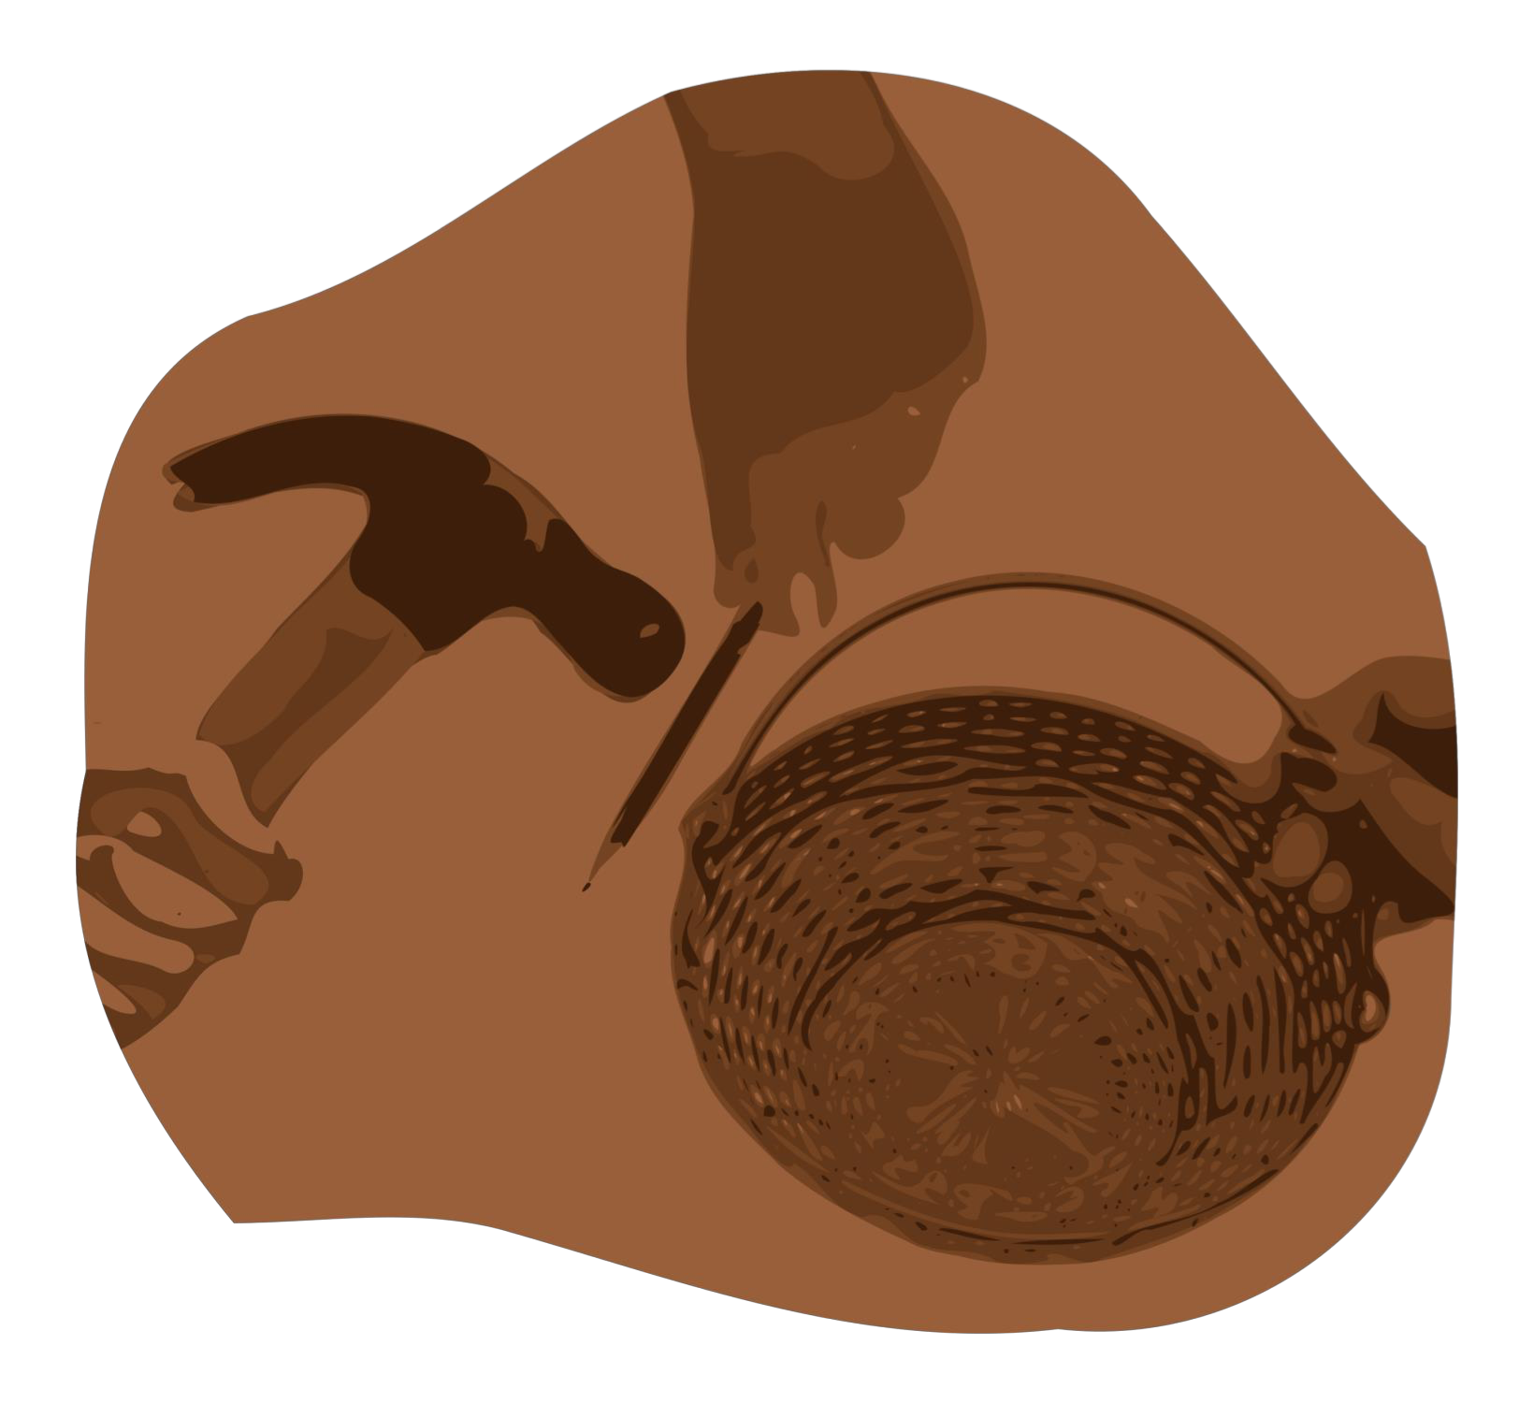
After learning about how Jesus wants us to make the world a better place by living out our faith, we’ll be inspired to do a Big Church Project! This week we’ll be inspired to thank and support frontline workers in Education. Kids are invited to ask Pastor Katie about this when they return next week!
Provided Supplies: Builder Book and Builder Bricks.
During Worship we’ll sing and dance along with our VBS Music. Kids can also listen to the Music on the Hero Hospital website.
Provided Supplies: Builder Book and Builder Bricks.

After sharing all of these activities and learning about faith during worship and at home with their families, our kids will be able to answer this week’s Big Question: How can you help those who care for people experiencing an illness or disability?
Provided Supplies: Builder Book and Builder Bricks.

Remember to bring back your finished art and science activities for Show and Tell!

