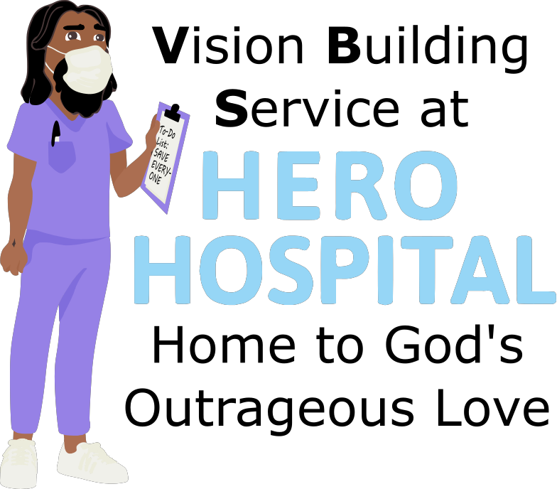
This week at Hero Hospital, we'll be learning that God's Kingdom is a
place for Heroes!
Instructions for activities are found at: bannerblue.org/herohospital
In Story, we'll learn from our historical guide Harriet and hear how Jesus was a hero and inspired others to be heroes by sharing God’s love!
Provided Supplies: Builder Book and Builder Bricks.

In Science, we'll experiment with building hovercrafts.
Provided Supplies: Builder Book and Builder Bricks, repurposed CDs/DVDs, tape, balloons.
Supplies from Home: Different types of bottle tops like a water bottle pop top or a shampoo bottle top.
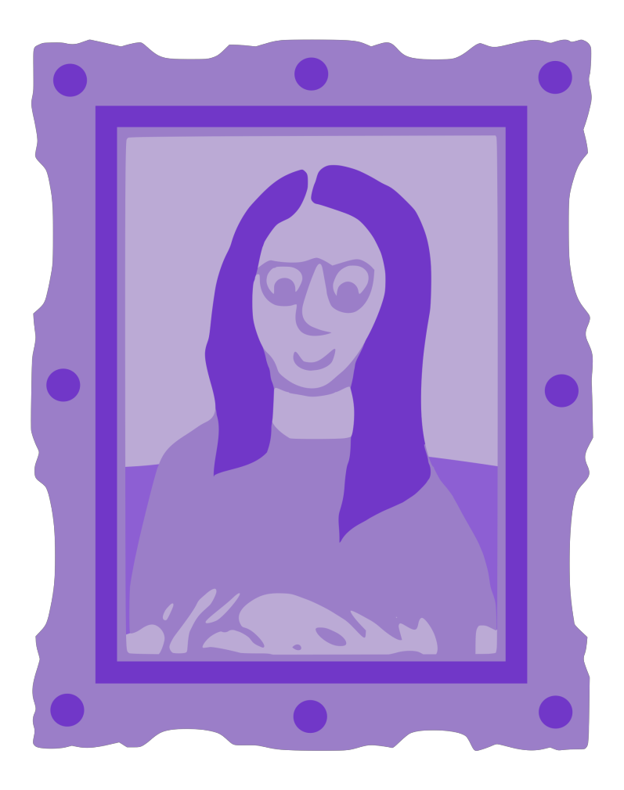
In Art, we’ll create Animal Tattoo Stamps.
Provided Supplies: Builder Book and Builder Bricks, washable markers, foam sheets, animal tattoo template.
Supplies from Home: scissors.
In Games, we’ll put a fun spin on Guess in 10 or Pictionary by using the Gospel Rules! Or you can find a creative version of tag on the website.
Provided Supplies: Builder Book and Builder Bricks.
Supplies from Home: Guess in 10 or Pictionary.

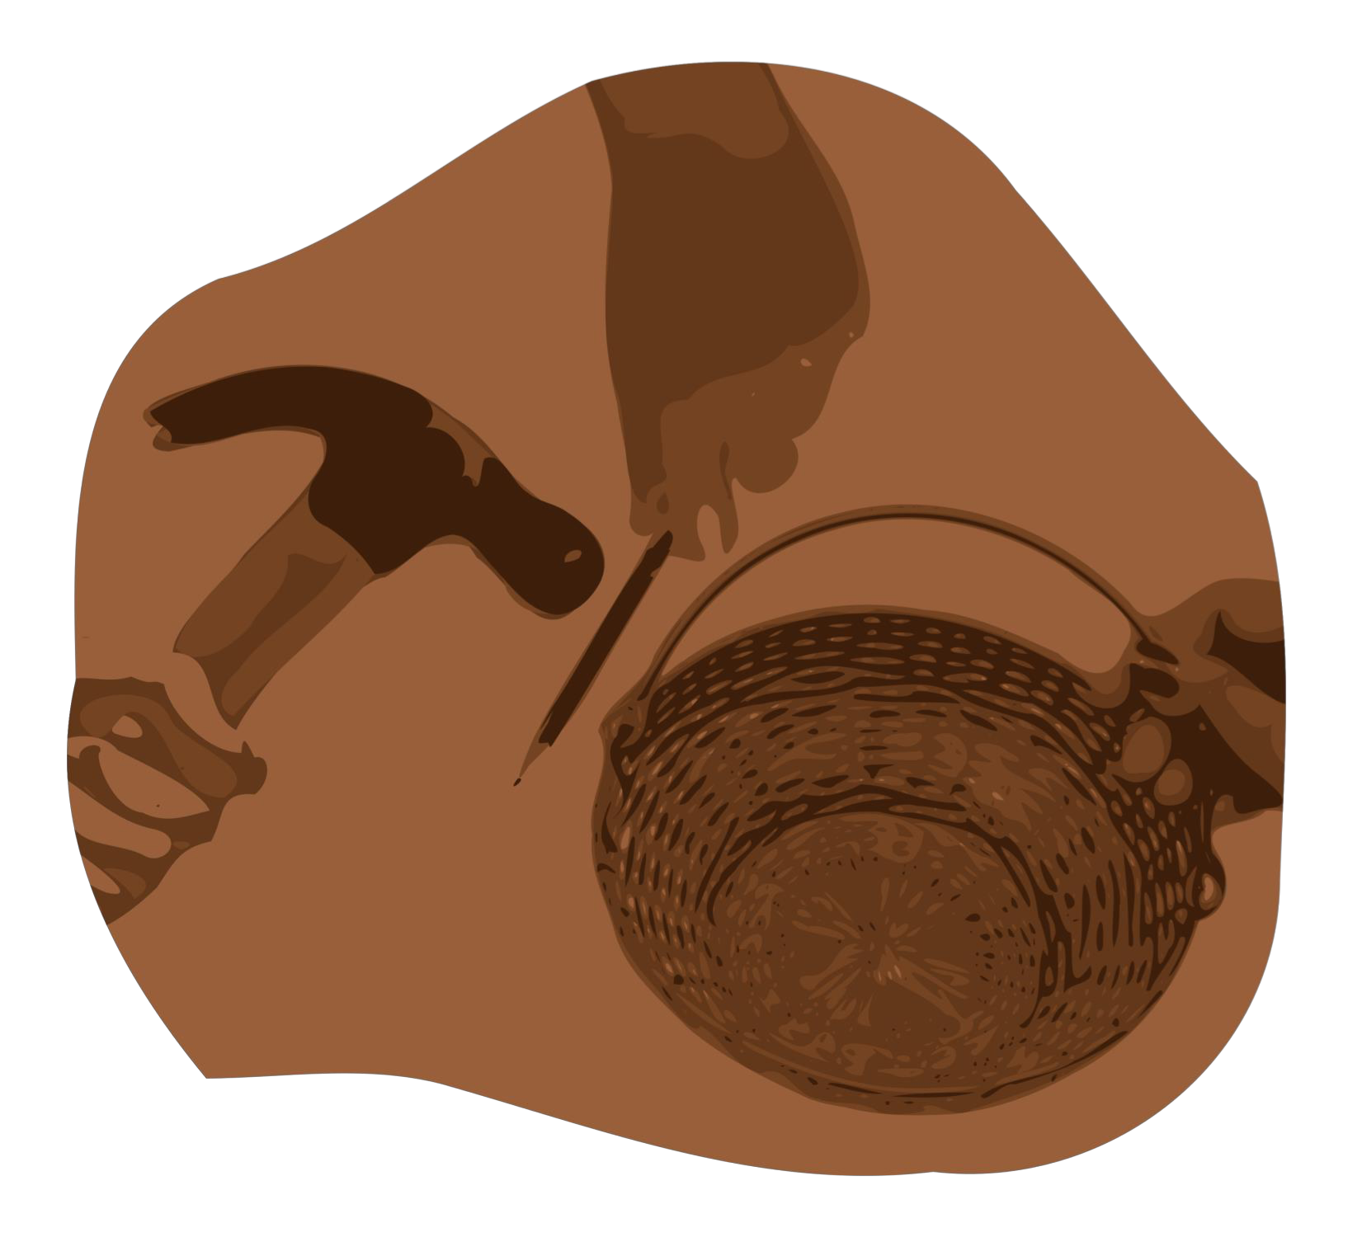
After learning about how Jesus wants us to make the world a better place by living out our faith, we’ll be inspired to do a Big Church Project! This week we’ll be inspired to learn more about mental health care. Kids are invited to ask Pastor Katie about this when they return next week!
Provided Supplies: Builder Book and Builder Bricks.
During Worship we’ll sing and dance along with our VBS Music. Kids can also listen to the Music on the Hero Hospital website.
Provided Supplies: Builder Book and Builder Bricks.

After sharing all of these activities and learning about faith during worship and at home with their families, our kids will be able to answer this week’s Big Question: What should you do if your friend experiences an illness or disability?
Provided Supplies: Builder Book and Builder Bricks.

Remember to bring back your finished art and science activities for Show and Tell!

