Worship Connection - Tree of Life
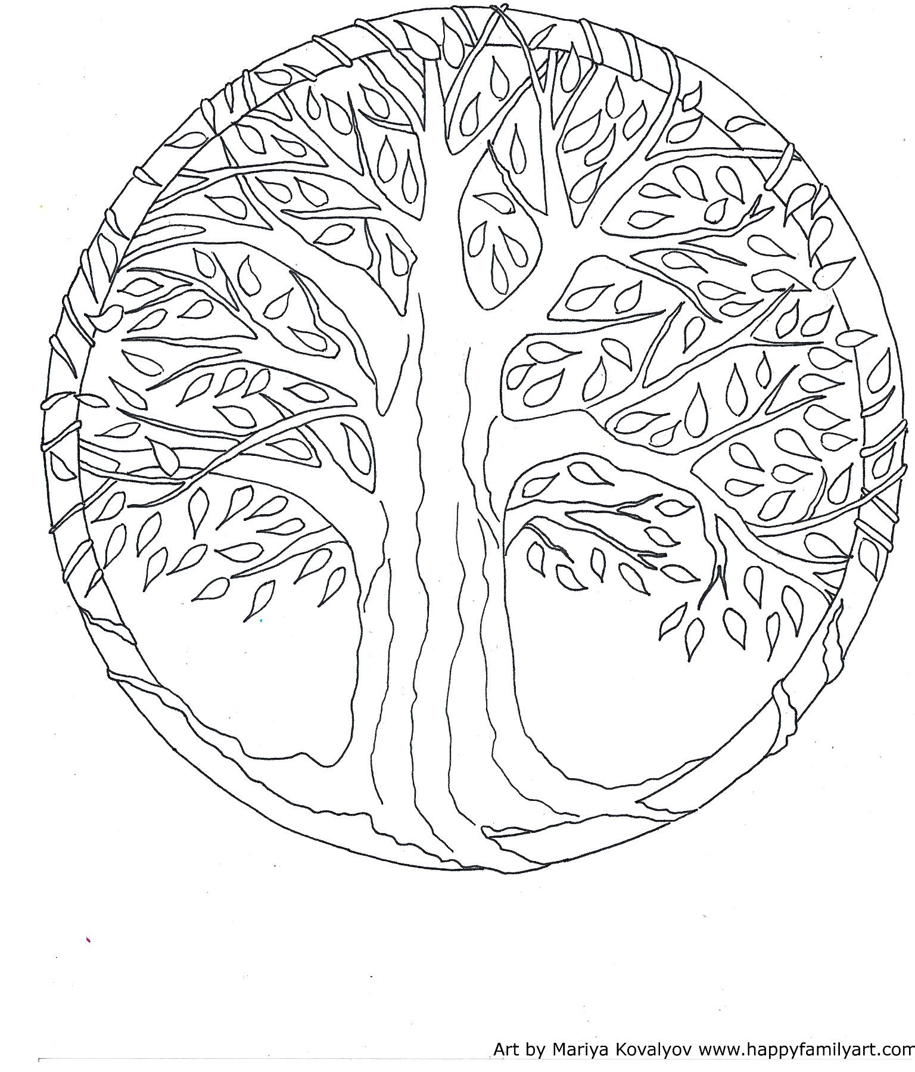
The word Lent comes from an old English word that meant “spring,” but the root is from a Latin word that means “slow.” When we think about how slowly the seasons seem to move from winter to spring in Northeast Ohio, we can see how the two words became connected! Throughout the season of Lent, we are slowly moving toward Easter. We are moving from winter to spring, from cold to warm, from snow to blossoms, and from death to resurrection.

We included a black and white picture of a tree in this month’s kits, symbolizing the Tree of Life. You are encouraged to add detail and color to your tree, a little at a time, all throughout Lent. This will remind us that even though this time of year is often cold and gray, slowly, little by little, we are moving toward Easter. By Easter, you will have slowly created a beautiful tree, full of the beauty of spring!

